TITLE - STUDENT PERFORMANCE PROJECT WEBSITE -
ABHISHEK GUPTA 12023002001101

Generated code may be subject to a license | Matt602/kaggle_breast_cancer_wisconsin
import pandas as pd import numpy as np
import matplotlib.pyplot as plt import seaborn as sns

data = pd.read_csv('/content/StudentPerformanceFactors.csv') data.head()
Generate code with data
 View recommended plots
New interactive sheet
Hours_Studied | Attendance | Parental_Involvement | Access_to_Resources | Extracurricular_Activities | Sleep_Hou
23 | 84 | Low | High | No
19 | 64 | Low | Medium | No
24 | 98 | Medium | Medium | Yes
29 | 89 | Low | Medium | Yes
19 | 92 | Medium | Medium | Yes

C

Next steps:

from google.colab import drive drive.mount('/content/drive')

Mounted at /content/drive

print(data.shape,"values")
print(f"So our dataset has {data.shape[0]} rows and {data.shape[1]} columns.")

(6607, 20) values
So our dataset has 6607 rows and 20 columns.

data.info()

<class 'pandas.core.frame.DataFrame'> RangeIndex: 6607 entries, 0 to 6606
Data columns (total 20 columns):
# Column Non-Null Count Dtype

0 Hours_Studied | 6607 | non-null |  | int64
1 Attendance | 6607 | non-null |  | int64
2 Parental_Involvement | 6607 | non-null |  | object
3 Access_to_Resources | 6607 | non-null |  | object
4 Extracurricular_Activities | 6607 | non-null |  | object
5 Sleep_Hours | 6607 | non-null |  | int64
6 Previous_Scores | 6607 | non-null |  | int64
7 Motivation_Level | 6607 | non-null |  | object
8 Internet_Access | 6607 | non-null |  | object
9 Tutoring_Sessions | 6607 | non-null |  | int64
10 Family_Income | 6607 | non-null |  | object
11 Teacher_Quality | 6529 | non-null |  | object
12 School_Type | 6607 | non-null |  | object
13 Peer_Influence | 6607 | non-null |  | object
14 Physical_Activity | 6607 | non-null |  | int64
15 Learning_Disabilities | 6607 | non-null |  | object
16 Parental_Education_Level | 6517 | non-null |  | object
17 Distance_from_Home | 6540 | non-null |  | object
18 Gender | 6607 | non-null |  | object
19 Exam_Score | 6607 | non-null |  | int64

dtypes: int64(7), object(13) memory usage: 1.0+ MB

data.describe()
 | Hours_Studied | Attendance | Sleep_Hours | Previous_Scores | Tutoring_Sessions | Physical_Activity | Exam_Sc
count | 6607.000000 | 6607.000000 | 6607.00000 | 6607.000000 | 6607.000000 | 6607.000000 | 6607.000
mean | 19.975329 | 79.977448 | 7.02906 | 75.070531 | 1.493719 | 2.967610 | 67.235
std | 5.990594 | 11.547475 | 1.46812 | 14.399784 | 1.230570 | 1.031231 | 3.890
min | 1.000000 | 60.000000 | 4.00000 | 50.000000 | 0.000000 | 0.000000 | 55.000
25% | 16.000000 | 70.000000 | 6.00000 | 63.000000 | 1.000000 | 2.000000 | 65.000
50% | 20.000000 | 80.000000 | 7.00000 | 75.000000 | 1.000000 | 3.000000 | 67.000
75% | 24.000000 | 90.000000 | 8.00000 | 88.000000 | 2.000000 | 4.000000 | 69.000
max | 44.000000 | 100.000000 | 10.00000 | 100.000000 | 8.000000 | 6.000000 | 101.000

C C

data.describe(include='O')
 | Parental_Involvement | Access_to_Resources | Extracurricular_Activities | Motivation_Level | Internet_Acce
count | 6607 | 6607 | 6607 | 6607 | 66
unique | 3 | 3 | 2 | 3
top | Medium | Medium | Yes | Medium | Y
freq | 3362 | 3319 | 3938 | 3351 | 61

C C

data.nunique()

 | 0
Hours_Studied | 41
Attendance | 41
Parental_Involvement | 3
Access_to_Resources | 3
Extracurricular_Activities | 2
Sleep_Hours | 7
Previous_Scores | 51
Motivation_Level | 3
Internet_Access | 2
Tutoring_Sessions | 9
Family_Income | 3
Teacher_Quality | 3
School_Type | 2
Peer_Influence | 3
Physical_Activity | 7
Learning_Disabilities | 2
Parental_Education_Level | 3
Distance_from_Home | 3
Gender | 2
Exam_Score | 45
C C

print(f"Mean Attendance of Students {data['Attendance'].mean()}")
print(f"Min Hours_Studied is {data['Hours_Studied'].min()} and maximum Hours_Studied is {data['Hours_Studied'].max print(f"Average Hours_Studied is {round(data['Hours_Studied'].mean())}")

Mean Attendance of Students 79.97744816104132
Min Hours_Studied is 1 and maximum Hours_Studied is 44 Average Hours_Studied is 20

Who have secured more score?

male=data['Gender'].value_counts()['Male'] female=len(data)-male
male,female

(np.int64(3814), np.int64(2793))

print(f"Percentage of females getting score {round((len(data.loc[(data['Gender']=='Female') & (data['Exam_Score']> print(f"Percentage of males getting score {round((len(data.loc[(data['Gender']=='Male') & (data['Exam_Score']>0)])

Percentage of females getting score 100.0% Percentage of males getting score 100.0%

plt.figure(figsize=(5,7))
plt.title('Score and Gender ')
sns.barplot(x='Gender',y='Exam_Score',data=data) plt.show()

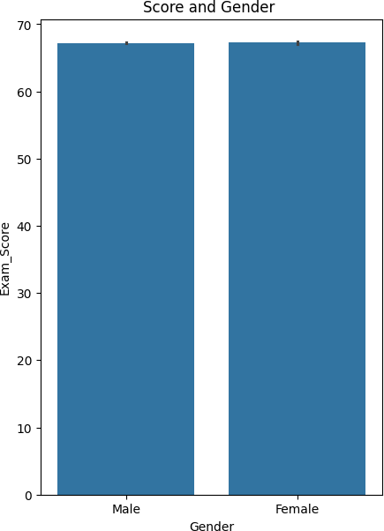
C C

Who have done more physical activity?

print(f"Percentage of females done activity {round((len(data.loc[(data['Gender']=='Female') & (data['Physical_Acti print(f"Percentage of males done activity {round((len(data.loc[(data['Gender']=='Male') & (data['Physical_Activity

Percentage of females done activity 99.21% Percentage of males done activity 99.37%

plt.figure(figsize=(5,7))
plt.title('Physical_Activity and Gender')
sns.barplot(x='Gender',y='Physical_Activity',data=data) plt.show()

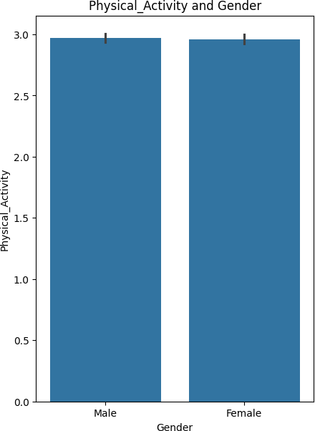
C C

Aggregate of Gender Using Mode Function

print(data.groupby('Hours_Studied')['Gender'].agg(lambda x: x.mode()[0]), '\n\n') # Use mode for categorical data print(data.groupby('Physical_Activity')['Gender'].agg(lambda x: x.mode()[0]), '\n\n') # Use mode for categorical d print(data.groupby('Attendance')['Gender'].agg(lambda x: x.mode()[0]), '\n\n') # Use mode for categorical data
print(data.groupby('Exam_Score')['Gender'].agg(lambda x: x.mode()[0]), '\n\n') # Use mode for categorical data
print(data.groupby('Previous_Scores')['Gender'].agg(lambda x: x.mode()[0]), '\n\n') # Use mode for categorical dat

Hours_Studied

  - Male
  - Male
  - Female
  - Male
  - Male
  - Male
  - Male
  - Male
  - Male
  - Male
  - Male
  - Male
  - Male
  - Male
  - Male
  - Male
  - Male
  - Male
  - Male
  - Male
  - Male
  - Male
  - Male
  - Male
  - Male
  - Male
  - Male

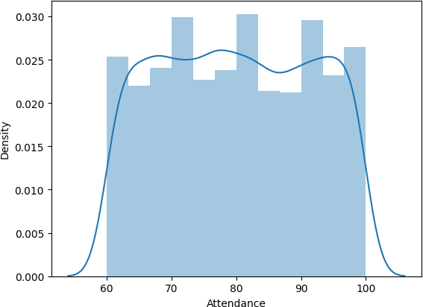
  - Male 
  - Female
  - Female
  - Male
  - Male
  - Male
  - Male
  - Male
  - Male
  - Male
  - Male
  - Male
- Female
- Female
Name: Gender, dtype: object

Physical_Activity
- Male
- Male
- Male
- Male
- Male
- Male
- Male
Name: Gender, dtype: object

Attendance

print(f"Aggregate of Gender Using Mode Function is {data.loc[data['Internet_Access']==1]['Gender'].median()}")

Aggregate of Gender Using Mode Function is nan

sns.distplot(data['Attendance'],bins=12) #Show a default plot with a kernel density estimate and histogram plt.show()

<ipython-input-21-6e57de9ceae5>:1: UserWarning:

`distplot` is a deprecated function and will be removed in seaborn v0.14.0.

Please adapt your code to use either `displot` (a figure-level function with similar flexibility) or `histplot` (an axes-level function for histograms).

For a guide to updating your code to use the new functions, please see https://gist.github.com/mwaskom/de44147ed2974457ad6372750bbe5751

sns.distplot(data['Attendance'],bins=12) #Show a default plot with a kernel density estimate and histogram

•

C C

Better chances to improve Performance

Male=data['Tutoring_Sessions'].value_counts()[1] Female=len(data)-Male
Male,Female

(np.int64(2179), np.int64(4428))

Gender Distribution

data['Gender'].value_counts()

count
Gender

Male 3814
Female 2793
C C

Most Common Motivation Level

data['Motivation_Level'].mode()[0]
C C

Average Hours Studied by School Type

data.groupby('School_Type')['Hours_Studied'].mean()

Hours_Studied
School_Type

Private 19.972623
Public 19.976512
C C

Most Frequent Access to Resources by Gender

data.groupby('Gender')['Access_to_Resources'].agg(lambda x: x.mode()[0])

Access_to_Resources
Gender

Female Medium
Male Medium
C C

Parental Education Level Counts

data['Parental_Education_Level'].value_counts()
Parental_Education_Level | count
High School | 3223
College | 1989
Postgraduate | 1305

C C

Average Sleep Hours by Physical Activity Level

data.groupby('Physical_Activity')['Sleep_Hours'].mean()
Physical_Activity | Sleep_Hours
0 | 7.108696
1 | 6.990499
2 | 7.021512
3 | 7.055796
4 | 7.004444
5 | 6.988920
6 | 7.343750

C C

Check for Missing Data

data.isnull().sum()

 | 0
Hours_Studied | 0
Attendance | 0
Parental_Involvement | 0
Access_to_Resources | 0
Extracurricular_Activities | 0
Sleep_Hours | 0
Previous_Scores | 0
Motivation_Level | 0
Internet_Access | 0
Tutoring_Sessions | 0
Family_Income | 0
Teacher_Quality | 78
School_Type | 0
Peer_Influence | 0
Physical_Activity | 0
Learning_Disabilities | 0
Parental_Education_Level | 90
Distance_from_Home | 67
Gender | 0
Exam_Score | 0
C C

sns.set(style="whitegrid")

Academic & Background Factors

fig, axes = plt.subplots(2, 2, figsize=(12, 10))
fig.suptitle('Academic & Background Factors', fontsize=16)

# Gender vs Exam Score
sns.barplot(x='Gender', y='Exam_Score', data=data, ax=axes[0, 0]) axes[0, 0].set_title('Gender vs Exam Score')

# School Type vs Hours Studied
sns.barplot(x='School_Type', y='Hours_Studied', data=data, ax=axes[0, 1]) axes[0, 1].set_title('School Type vs Hours Studied')
axes[0, 1].tick_params(axis='x', rotation=45)

# Motivation Level vs Exam Score
sns.barplot(x='Motivation_Level', y='Exam_Score', data=data, ax=axes[1, 0]) axes[1, 0].set_title('Motivation Level vs Exam Score')
axes[1, 0].tick_params(axis='x', rotation=45)

# Access to Resources vs Exam Score
sns.barplot(x='Access_to_Resources', y='Exam_Score', data=data, ax=axes[1, 1]) axes[1, 1].set_title('Access to Resources vs Exam Score')
axes[1, 1].tick_params(axis='x', rotation=45)

plt.tight_layout(rect=[0, 0.03, 1, 0.95]) plt.show()

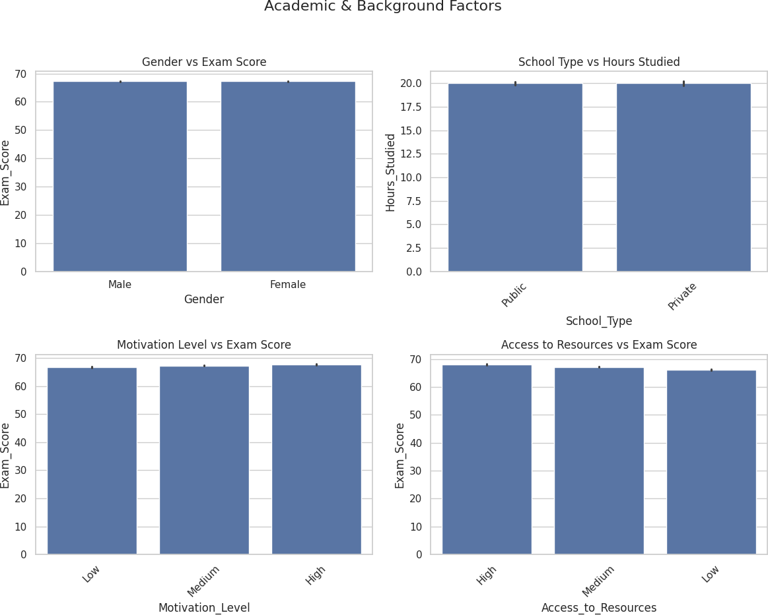

Digital & Social Environment

fig, axes = plt.subplots(1, 2, figsize=(12, 5))
fig.suptitle('Digital & Social Environment Factors', fontsize=16)

# Internet Access vs Hours Studied
sns.barplot(x='Internet_Access', y='Hours_Studied', data=data, ax=axes[0]) axes[0].set_title('Internet Access vs Hours Studied')
axes[0].tick_params(axis='x', rotation=45)

# Extracurricular Activities vs Exam Score
sns.barplot(x='Extracurricular_Activities', y='Exam_Score', data=data, ax=axes[1]) axes[1].set_title('Extracurricular Activities vs Exam Score')
axes[1].tick_params(axis='x', rotation=45)

plt.tight_layout(rect=[0, 0.03, 1, 0.95]) plt.show()

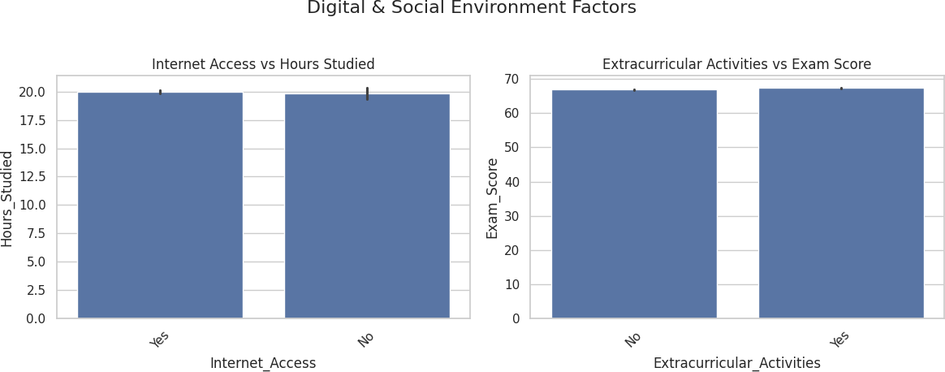

Health & Financial Factors

# Categorize sleep hours
data['Sleep_Category'] = pd.cut(data['Sleep_Hours'], bins=[0, 4, 6, 8, 10], labels=['<5', '5-6', '6-8', '8+'])

fig, axes = plt.subplots(1, 2, figsize=(12, 5))
fig.suptitle('Health & Financial Factors', fontsize=16)

# Sleep Hours vs Exam Score
sns.barplot(x='Sleep_Category', y='Exam_Score', data=data, ax=axes[0]) axes[0].set_title('Sleep Hours vs Exam Score')

# Family Income vs Exam Score
sns.barplot(x='Family_Income', y='Exam_Score', data=data, ax=axes[1]) axes[1].set_title('Family Income vs Exam Score')
axes[1].tick_params(axis='x', rotation=45)

plt.tight_layout(rect=[0, 0.03, 1, 0.95]) plt.show()
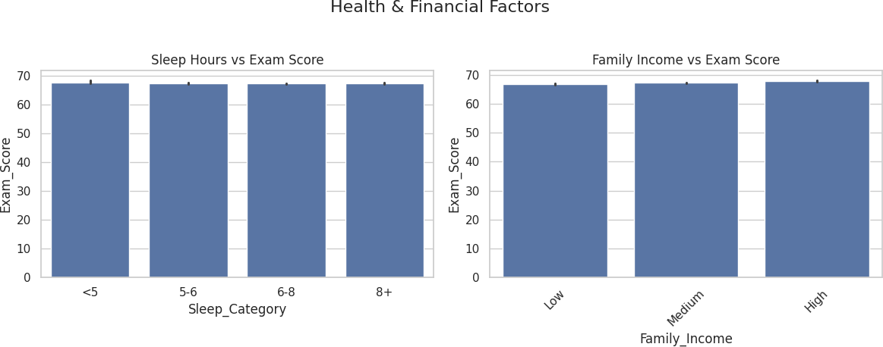

Correlation between features

# Select only numeric columns before calculating correlation numeric_data = data.select_dtypes(include=np.number)
correlation_matrix = numeric_data.corr()

# Display the correlation matrix print(correlation_matrix)
 | Hours_Studied | Attendance |  | Sleep_Hours | Previous_Scores | \
Hours_Studied | 1.000000 | -0.009908 |  | 0.010977 | 0.024846
Attendance | -0.009908 | 1.000000 |  | -0.015918 | -0.020186
Sleep_Hours | 0.010977 | -0.015918 |  | 1.000000 | -0.021750
Previous_Scores | 0.024846 | -0.020186 |  | -0.021750 | 1.000000
Tutoring_Sessions | -0.014282 | 0.014324 |  | -0.012216 | -0.013122
Physical_Activity | 0.004624 | -0.022435 |  | -0.000378 | -0.011274
Exam_Score | 0.445455 | 0.581072 |  | -0.017022 | 0.175079
 | Tutoring_Sessions |  | Physical_Activity |  | Exam_Score
Hours_Studied | -0.014282 |  | 0.004624 |  | 0.445455
Attendance | 0.014324 |  | -0.022435 |  | 0.581072
Sleep_Hours | -0.012216 |  | -0.000378 |  | -0.017022
Previous_Scores | -0.013122 |  | -0.011274 |  | 0.175079
Tutoring_Sessions | 1.000000 |  | 0.017733 |  | 0.156525
Physical_Activity | 0.017733 |  | 1.000000 |  | 0.027824
Exam_Score | 0.156525 |  | 0.027824 |  | 1.000000

# Select only numeric columns before calculating correlation numeric_data = data.select_dtypes(include=np.number)
correlation_matrix = numeric_data.corr()

# Display the correlation matrix as a heatmap
sns.heatmap(correlation_matrix, annot=True, cmap='coolwarm') plt.show()
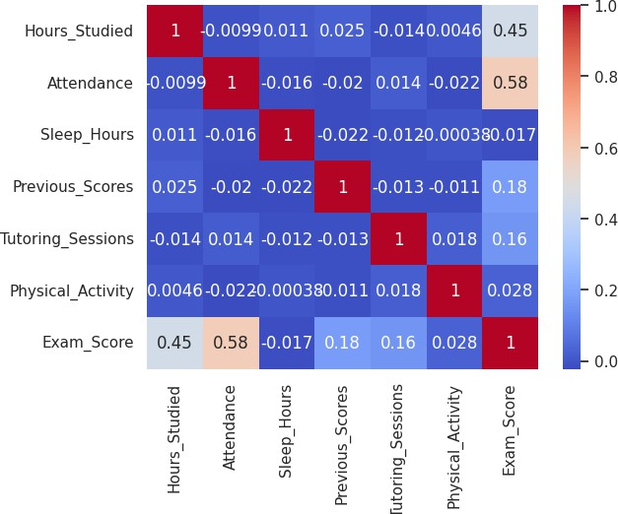
C
C

Male female ratio in dataset

data['Gender'].value_counts()

count
Gender

Male 3814
Female 2793
C C

plt.figure(figsize=(5,7))
sns.countplot(data=data, x='Gender',palette='Accent') plt.show()

<ipython-input-42-0119ae097d2a>:2: FutureWarning:
Passing `palette` without assigning `hue` is deprecated and will be removed in v0.14.0. Assign the `x` variabl sns.countplot(data=data, x='Gender',palette='Accent')
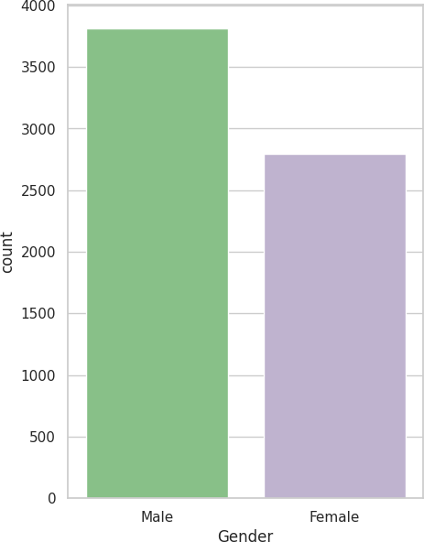
C C

print(f"Percentage of Male in Students {round(data['Gender'].value_counts()['Male']/len(data['Gender'])*100,2)}%") Percentage of Male in Students 57.73%
print(f"Percentage of Female in Students {round(data['Gender'].value_counts()['Female']/len(data['Gender'])*100,2) Percentage of Female in Students 42.27%
data.loc[data['Parental_Involvement']==1]['Parental_Education_Level'].value_counts()

count
Parental_Education_Level
C C

plt.subplots(3,2,figsize=(14,12)) plt.subplot(321)
sns.barplot(y='Parental_Involvement',x='Gender',data=data,estimator=np.median)

plt.subplot(322)
sns.barplot(y='Parental_Involvement',x='Exam_Score',data=data,estimator=np.median)

plt.subplot(323)
sns.boxplot(y='Parental_Involvement',x='Family_Income',data=data)

plt.subplot(324)
sns.barplot(y='Parental_Involvement',x='Attendance',data=data)

plt.subplot(325)
sns.barplot(y='Parental_Involvement',x='Motivation_Level',data=data)

plt.subplot(326)
sns.barplot(y='Parental_Involvement',x='Access_to_Resources',data=data)

plt.tight_layout() # to adjust the padding between the subplots plt.show()

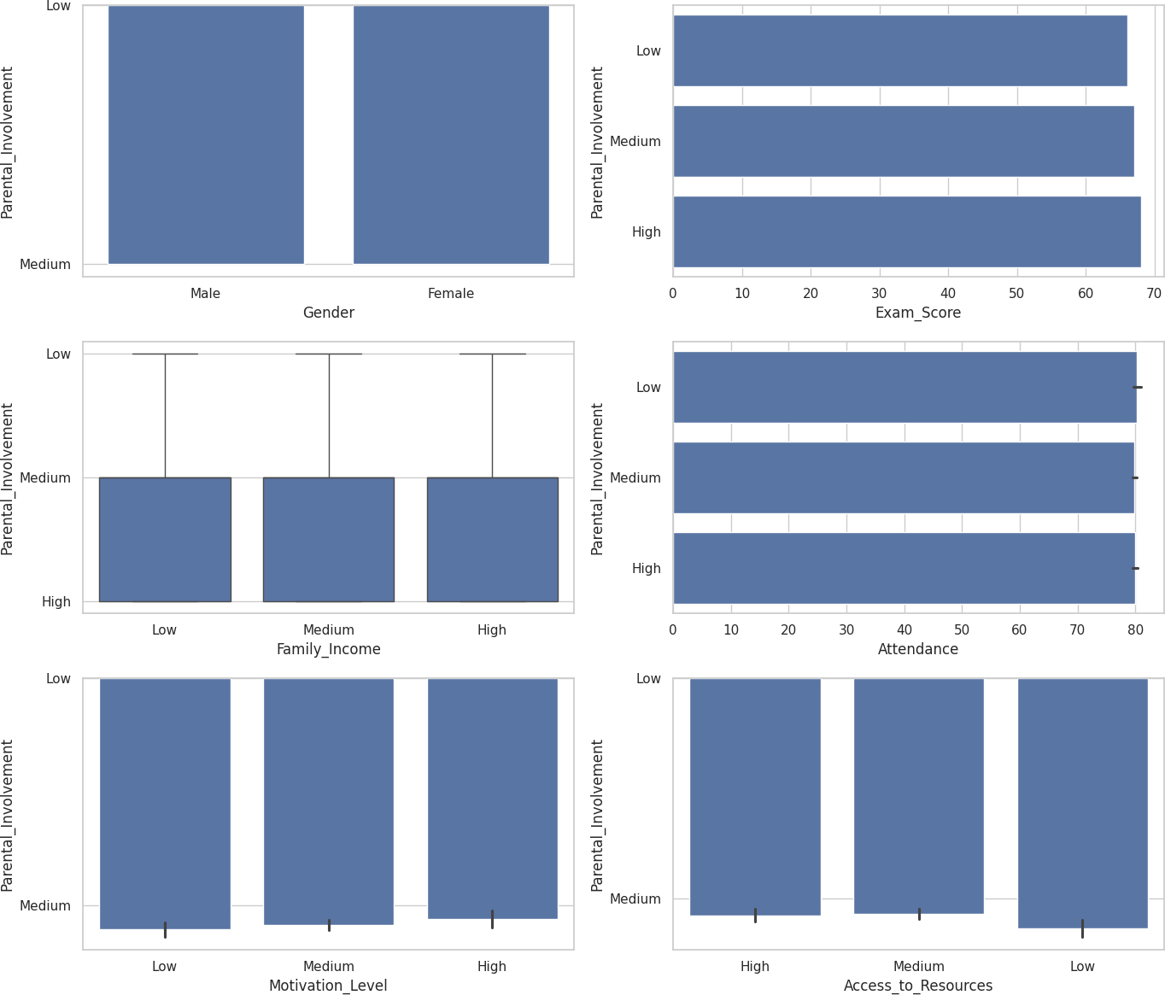

Feautres with respect to backlog

# exam score with respect to gender plt.figure(figsize=(8,4))
sns.barplot(x='Exam_Score',y='Attendance',data=data,hue='Gender',estimator=np.mean) plt.show()

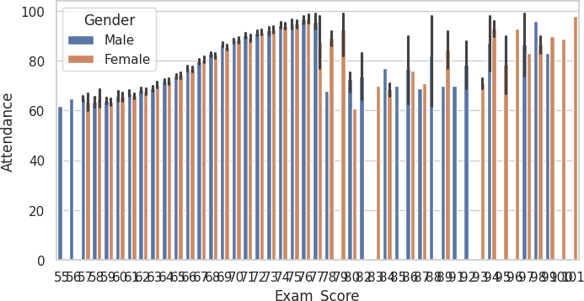

df=data.groupby('Attendance')['Exam_Score'].mean() df

Attendance | Exam_Score
60 | 62.413793
61 | 63.384146
62 | 63.756579
63 | 64.361290
64 | 63.884615
65 | 63.905063
66 | 64.537931
C |  | C
67 | 64.626316
68 | 65.147059
69 | 65.123529
70 | 65.527950
71 | 65.611111
72 | 65.694611
73 | 65.952381
74 | 66.272727
75 | 66.288591
76 | 66.886486
77 | 66.668478
78 | 66.890909

